Part1【PTZ Function Operation and Description】
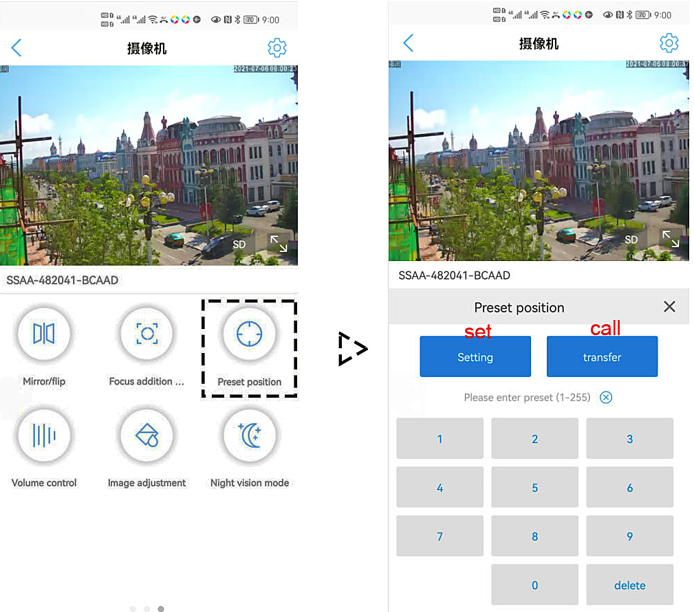
Mobile APP interface description

Professional name explanation;
Set:set preset, Call:Call preset
[N]+[set]=Enter N first and then click SET.
“+”=Then

1, How to use tracking Features
1) Fixed point tracking:
Before turning on the track function, you need to set
the return position (return position) after the end of the
track. Then turn on tracing. In the case of no tracking
action, the camera is waiting at the return position, The
camera is turned on when the person is detected. After
tracking is completed, the camera automatically returns
to the return position and continues to wait for the next tracking.The return position is 88th preset.please set 88th preset
Call 97 for Turn on tracking, Setting method: [97]+[Call]; set 96 for turn off tracking, Setting method: [96]+[Set]
2)Cruise tracking:
Before turning on tracking, you need to set the camera's cruise point in advance. A maximum of 16 preset points can be set. These cruise points are the few locations you want to monitor. The camera will cruise back and forth between these locations to find a tracking target. Really made a camera monitors multiple angles of demand. Turn on cruise trackingfunction,The camera will cycle moving through the preset cruise points. When the person is detected, the camera will turn on the tracking. After the tracking is completed, the camera automatically resumes the cruise until the next time the person is detected, the tracking is turned on again
Set 1,2,3,4….max 16 preset position,Then call 98th preset camera will auto turn on cruise tracking
Setting method: [98]+[Call] for turn on cruise
2,Preset settings: Rotate the camera to the position you want, then set this position to “N” preset
[N] +[SET] ,N is preset point, 1-255 number can be optional (But the command Preset isn’t include). Set= set preset
3.Call preset( need set the corresponding preset point) : [N]+[CALL]
4.Delete all preset point: [100] +[CALL] ,Call no.100 preset, clear the all preset :[1]+[0]+[0]+[CALL] .
5.Auto scan(Horizontal rotation) : [120]+[CALL], call No.120 ,the lever of 360 degree clockwise automatic scanning
Modify speed of Auto scan :[121]+[Set] +[N]+[Set]; (N=1-10; N represents scan speed percentage,default is 8=80%)
If you wanto to change speed of auto scan to 50%; Setting method: [121]+[Set] +[5]+[Set]
6.The inspection group programming
Before you start cruising, you first need to set the preset position in the cruise path.Please refer to “ 2.Preset settings”
[101]+[CALL] for Open the first Cruise of 1-16 to scan
Modify the stay time of the Cruise:
[123] +[Set] + [N]+[Set]; (N=3-10; N represents the dwell time at each preset,default is 5 seconds)
If you change the dwell time to 10 seconds. Setting method:[123]+[Set] + [10]+[Set]
Modify speed of the Cruise:[115]+[Set] + [N]+[Set]; (N=1-10; N represents Cruising speed percentage,default is 8=80%)
If you change speed of the Cruise to 40%; Setting method:[115]+[Set] + [4]+[Set]
7.Left and right limit scan settings
The users can set left and right limit point in the range of the rotation, the speed dome can return scan in setting range [81]+[SET]: left limit; [82]+[SET]: right limit, [83]+[CALL]: start right and left limit scan
Modify the speed of right and left limit scan:
- +[SET]+[N] +[SET]; (N=1-10; N represents Cruising speed percentage,default is 5=50%)
If you change speed of the limit scan to 100%; Setting method:[141]+[Set] + [10]+[Set]

Part 2【Common functions operating Express 】
Function name | Explanation | Preset | Call | Set
Turn OFF auto tracking | Turn off auto tracking (default) | 96 |  | √
Turn On auto tracking | Turn On auto tracking | 97 | √
Turn on cruise tracking | Turn on some preset position cruise tracking | 98 | √
Set return position | position of the camera return after the end of the tracking | 88 |  | √
Return position wait time | 153+Set+N+Set,N=1-15 seconds ,default N=5 Seconds | 153 |  | √
Tracking zoom control | 95+set for turn on ZOOM(default);95+call for turn off Zoom when camera tracking | 95 | √ | √
Set tracking Pan speed | 150+set+N+set，N=1-10,default N=3 | 150 |  | √
Set tracking Tilt speed | 151+set+N+set，N=1-10, default N=3 | 151 |  | √
Recover Fix position tracking time | Automatically recover the fixed point tracking time after manually controlling the camera :  158+set+N+set，N=1-10 minute ，default N=1 minute | 158 |  | √
Recover cruise tracking time | Automatically recover the Cruise tracking time after manually controlling the camera :  159+set+N+set，N=1-10 minute ，default N=1 minute | 159 |  | √
IR light auto mode | Infrared light is controlled by changes in light brightness | 137 | √
IR light Forced on mode | IR light is always on, and the camera stays in night mode. | 138 | √
IR light Forced to close | IR light is always off during , and the camera is in day mode | 139 | √
IR detection threshold setting | Set 91+Set N (N=1-10;N represents Ambient light brightness,1-10=0.1Lux-1LUX ) | 91 |  | √
Dipped beam and high beam switch | The user can arbitrarily set the near light and the remote light to switch position. | 92 | √
Full IR open | The user can arbitrarily set the position where the near light and the far light are simultaneously turned on. | 93 | √
IR brightness adjustment | brightness set for all IR: set 122 + set N, (N=1-10; default is 8=80%) | 122 |  | √
Auto scan(pan) | the lever of 360 /355 degree clockwise automatic scanning | 120 | √
Modify speed of Auto scan | Set 121+set N(N=1-10; N represents scan speed percentage,default is 8=80%) | 121 |  | √
Open the first cruise | Open the first cruise (Support 1-32 presets) | 101 | √
Set cruise speed | Set 115+set N(N=1-10; N represents Cruising speed percentage,default is 8=80%) | 150 |  | √
Modify the stay time of the Cruise | Set 123+set N(N=3-10; N represents the dwell time at each preset,default is 5 seconds) | 123 |  | √
Left limit | Set Left limit | 81 |  | √
Right limit | Set Right limit | 82 |  | √
Open limit scan | Open limit scan | 83 | √
Modify the speed limit scan | Modify the speed of right and left limit scan:Set 141+set N (N=1-10; N represents Cruising speed percentage,default is 5=50%) | 141 |  | √
Set and open the watch position | Rotate the camera to the position you want, then set 125([125]+[PRESET]), and the current position is the watch position, and turn this feature on. When the camera is in standby, the camera will automatically rotate to this position | 125 |  | √
Delete watch position |  | 125 | √
Set the watch start time | Set 126+set N(N=1-10 ; N represents start time,default is 5 minutes) | 126 |  | √
Open Idle action | Open Idle action | 130 | √
Close Idle action | Close Idle action | 130 |  | √
Idle action Setting | Set 131+Call N,N=Function preset | 131 |  | √
Set the time the idle action | Set the time when the idle action starts:Set 132+set N (N=1-30; N represents Idle time,default is 5 minutes) | 132 |  | √
Lens focal length and speed match | PTZ speed, lens zoom automatic matching is enabled (default is on) | 108 | √
Len and speed match | Close Lens focal length and speed match,Turn off automatic matching | 108 |  | √
Wiper control | 71+call (after executing once, the wiper will automatically stop after wiping 3 times, and can be operated repeatedly) | 71 | √
Defog control | 72+call: Enable defogging function. 72+Settings: Turn off the defogging function. | 72 | √
Defog time | Set the working duration of defogging: 73+settings+N+settings, N=1-24 hours, default N=1 hour (automatically closed after 1 hour of activation) | 73 |  | √
Modify manual control Pan Speed | 160+set+N+set，N=1-10，default N=8 | 160 |  | √
Modify manual control tilt Speed | 161+set+N+set，N=1-10，default N=8 | 161 |  | √
Auto focus mode | 250+set+N+call,  When N=1 auto focus only when controll ZOOM( Manual + automatic mode),  When N=2 auto focus when any one of P/T/Z changed( automatic mode),  When N=3 auto focus when any one of P/T/Z/video changed(full automatic mode) | 250 |  | √
Focus distance setting | 251+set+N+Call  When N=1 Minimum focusing distance: 1.5 meters  When N=2 Minimum focusing distance: 3 meters  When N=3 Minimum focusing distance: 6 meters | 251 |  | √
Autofocus self-learning | 253+set+252+call (The camera will automatically perform autofocus self-learning (the distance between the object and the camera must be greater than 50 meters), please use it with caution.) | 253 |  | √
Delete all preset point | Delete all preset point | 100 | √
pan/tilt correction | Setting method:[107]+[Set]+[64]+[CALL] | 107 | √
Restore factory settings | Setting method:[106]+[Call]+[64]+[CALL] | 106 | √

